
Artificial Intelligence (LAB)
Lab Report 3

Submitted By:
Fiza Mushtaq
SU92-BSSEM-S25-016
BSSEM-4A

Submitted To:
SIR. Rasikh Ali

Task 1:
- BFS and DFS Trace
Graph:
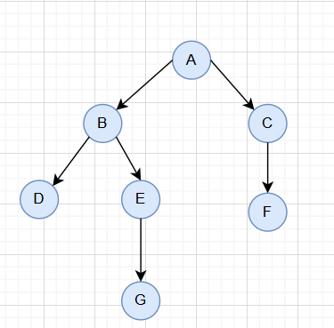

Start Node: A
Goal Node: G
Breadth-First search:
Breadth First search goes level by level. This means that we look at every node attached to A then move onto the next level. We use a queue to manage the nodes.
step | Node in queue | Queue after processing | Path
1 | A | B, C | A
2 | B | C, D, E | A->B
3 | C | D, E, F | A->C
4 | D | E, F | A->B->D
5 | E | F, G | A->B->E
6 | F | G | A->C->F
7 | G | Empty | A->B->E->G
Path: A->B->E->G
Order of nodes visited: A->B->C->D->E->F->G

Depth-First Search:
Depth first search will follow down the first branch it can find until it can go back and follow another branch. Again we are using stack to manage the nodes. As we have an order we will visit D before E. we will stop when we reach G.
step | Node in stack | Stack after processing | Path
1 | A | C, B | A
2 | B | C, E, D | A->B
3 | D | C, E | A->B->D
4 | E | C, G | A->B->E
5 | G | C | A->B->E->G

Path: A->B->E->G
Order of nodes visited: A->B->D->E->G
Using the Code:
We should get back the same paths
['A', 'B', 'E', 'G']
['A', 'B', 'E', 'G']
This gives us the same path
Task 2:
- Depth Limited Search
DLS:
Depth limited search will search the graph but will not go deeper than a certain depth. A has depth of 0 and G has a depth of 3.
Max depth | Result | Path
1 | CUTOFF | Not Found
2 | CUTOFF | Not Found
3 | FOUND | A->B->E->G
4 | FOUND | A->B->E->G
Explanation:
Depth limits 1 and 2 do not succeed because the goal node G is at depth 3. At these limits the search stops before reaching G and returns CUTOFF. When the depth limits is 3 or 4 the goal is found through the path A->B->E->G

Meaning of Results:
FOUND= The goal was reached
CUTOFF= We could not go any further down the branch as it was limited by depth
FAILURE= Could not find the goal and had no cutoff

